11422006_Parallel Coordinates

*by* Perpustakaan IT Del

Submission date: 26-Feb-2025 10:35AM (UTC+0700)

Submission ID: 2597153029

File name: 11422006_Parallel_Coordinates.pdf (280.75K)

Word count: 1205

Character count: 7996

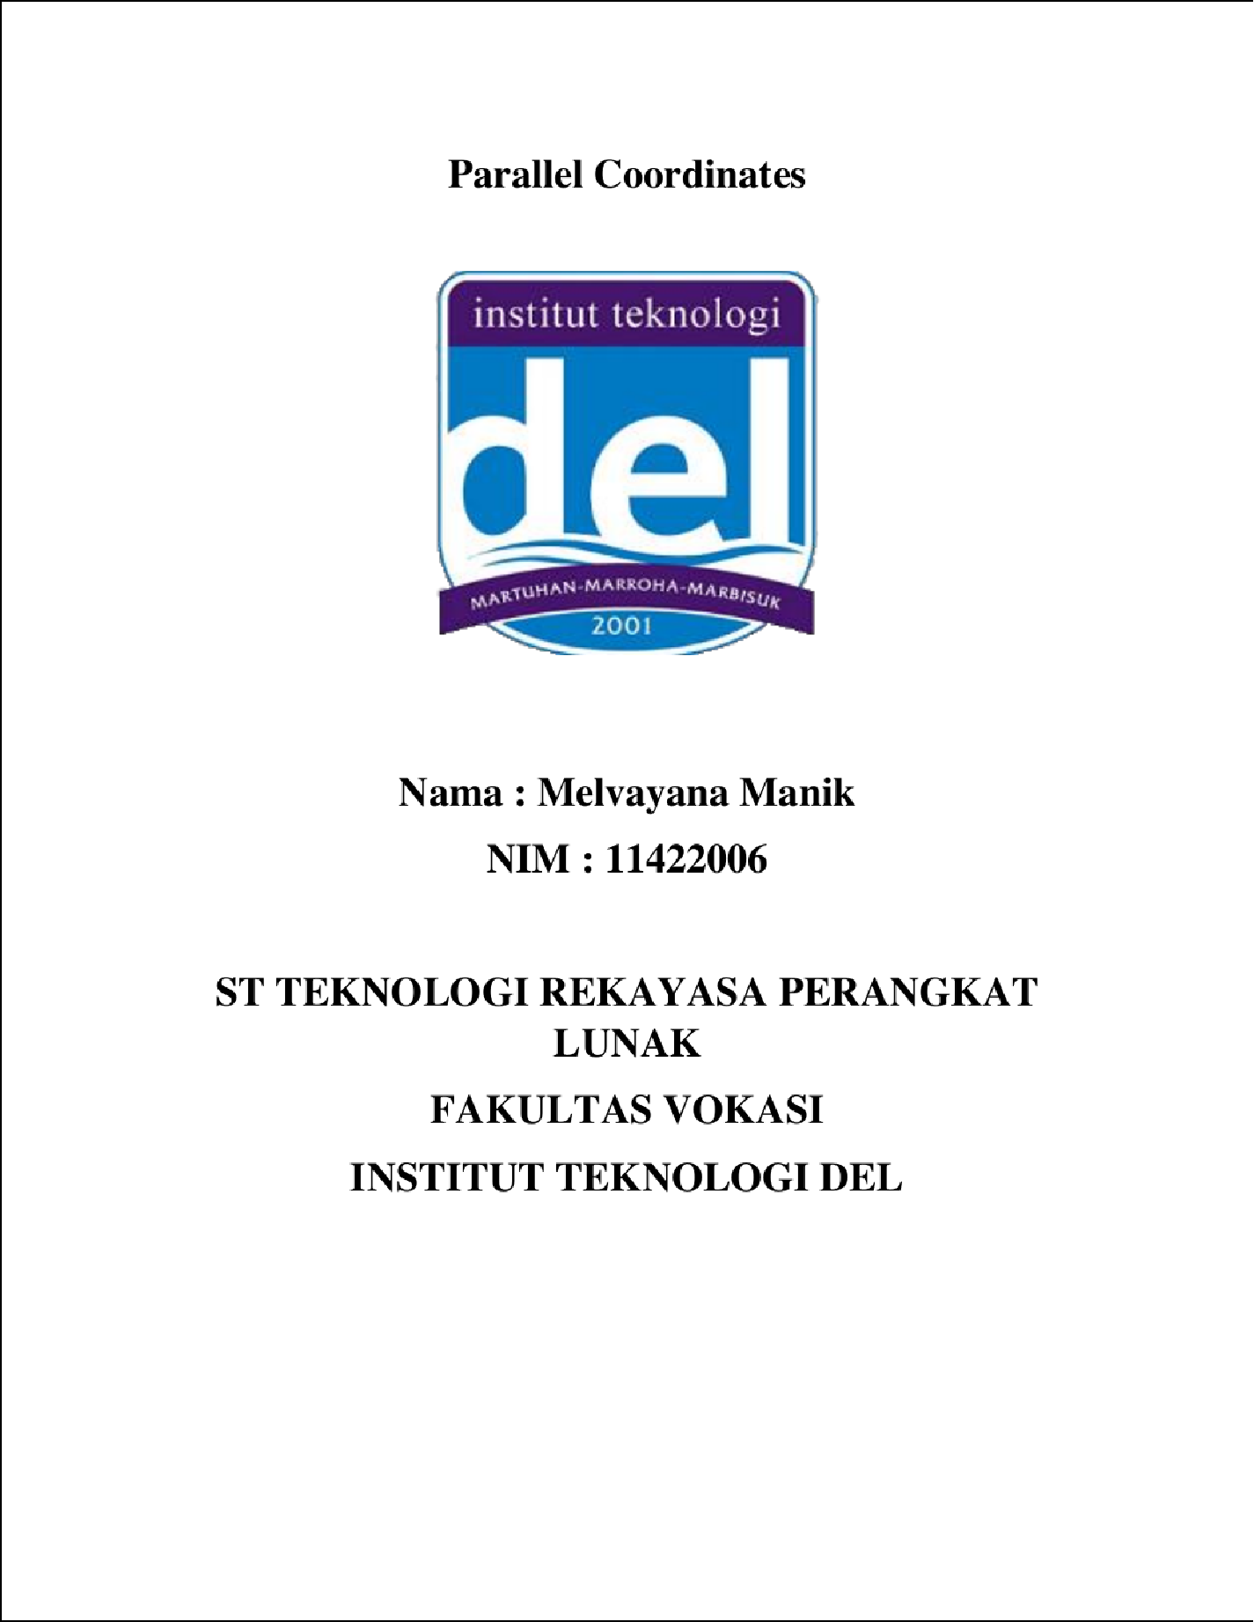

2

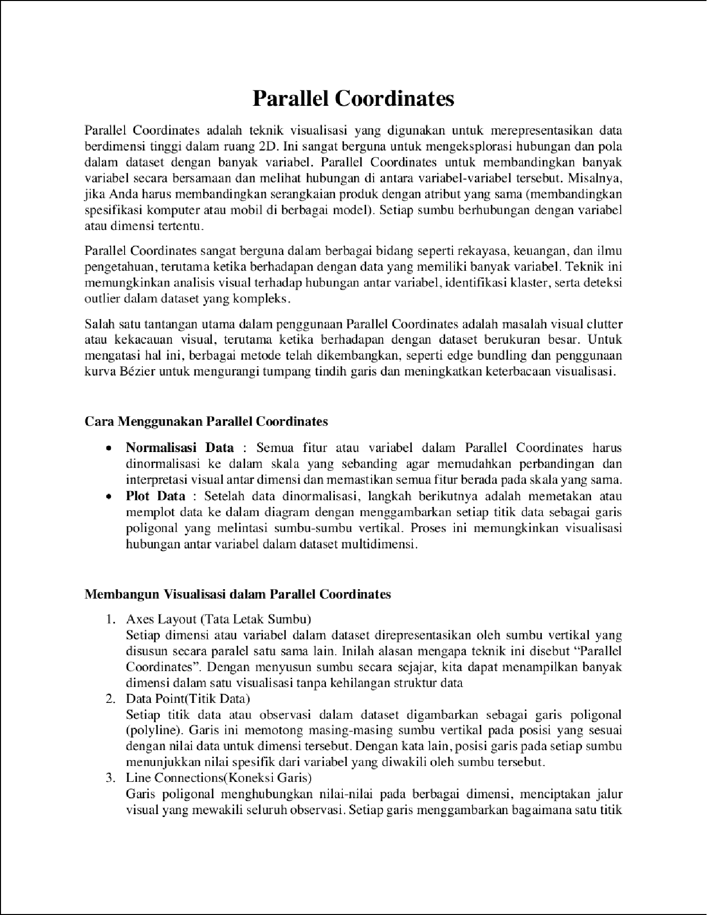

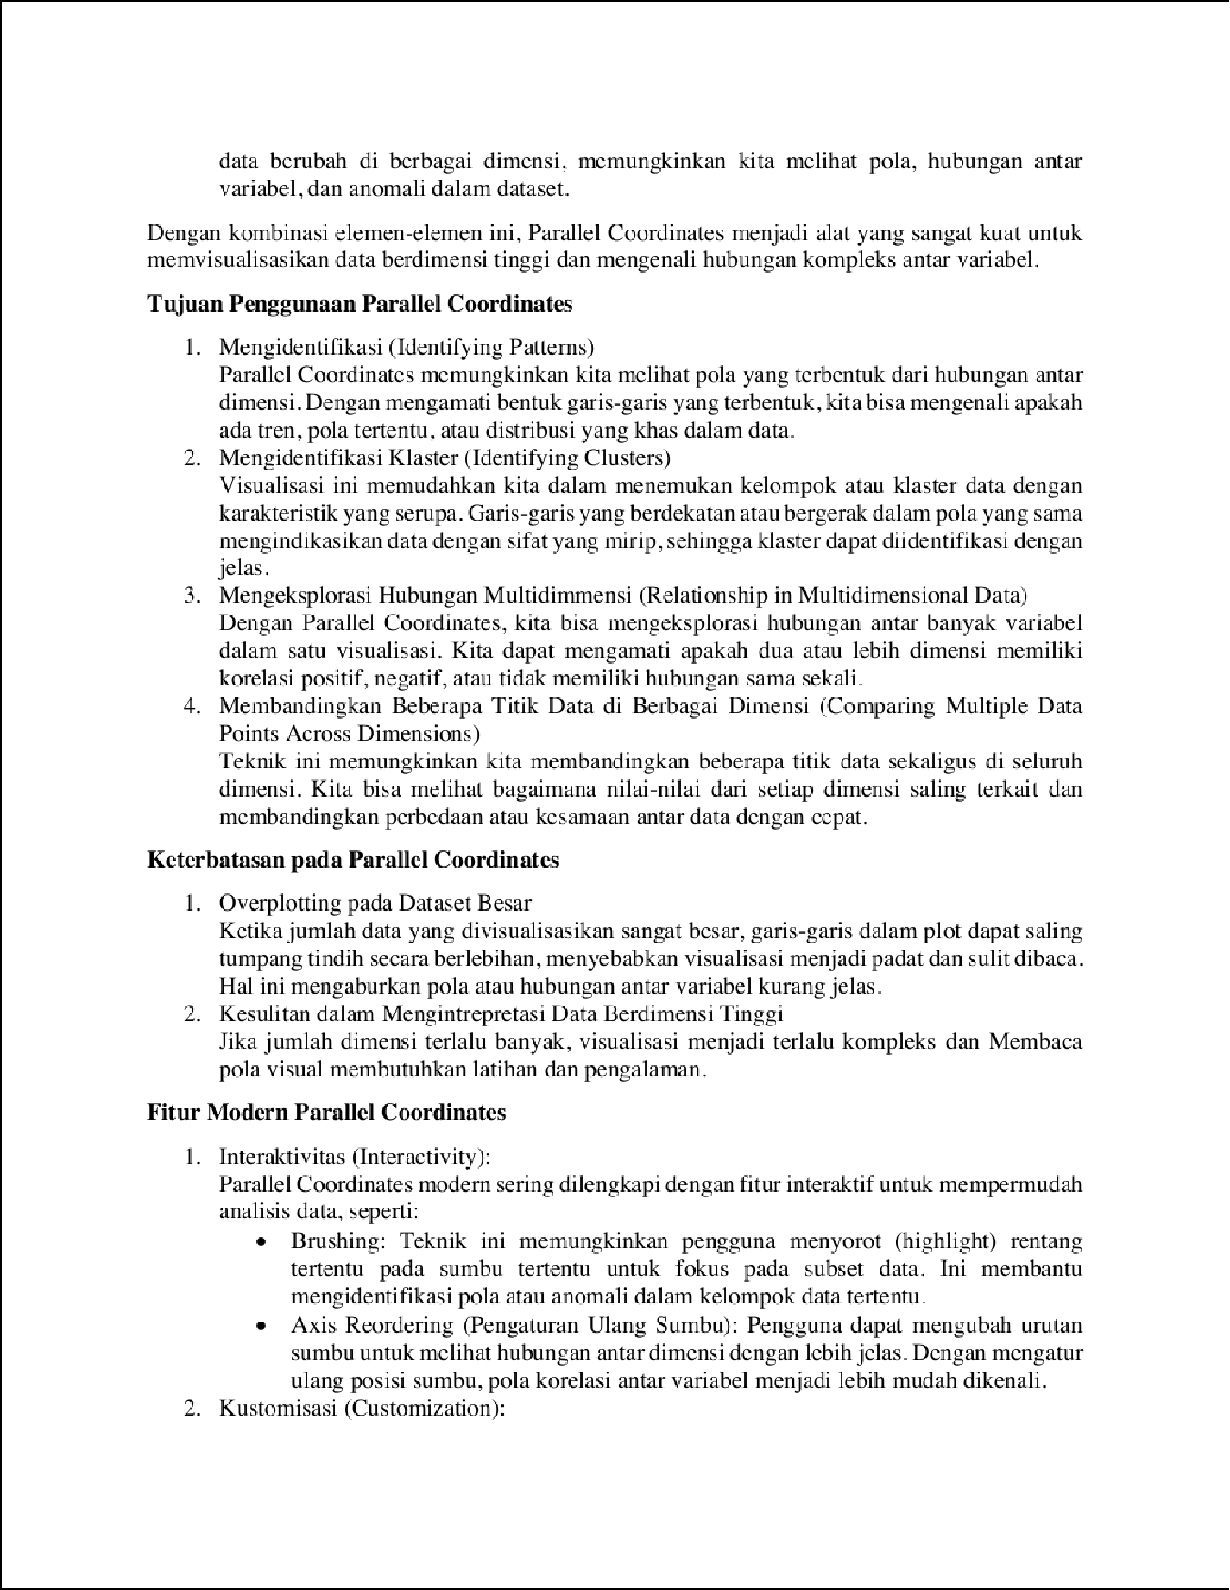

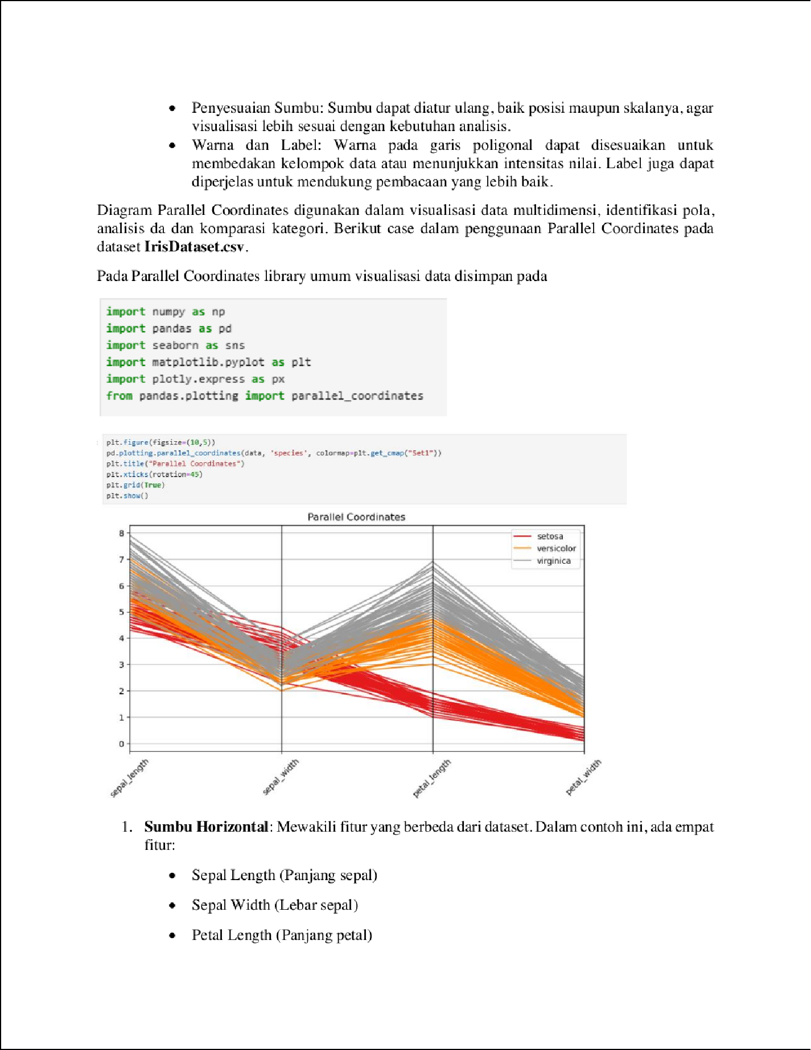

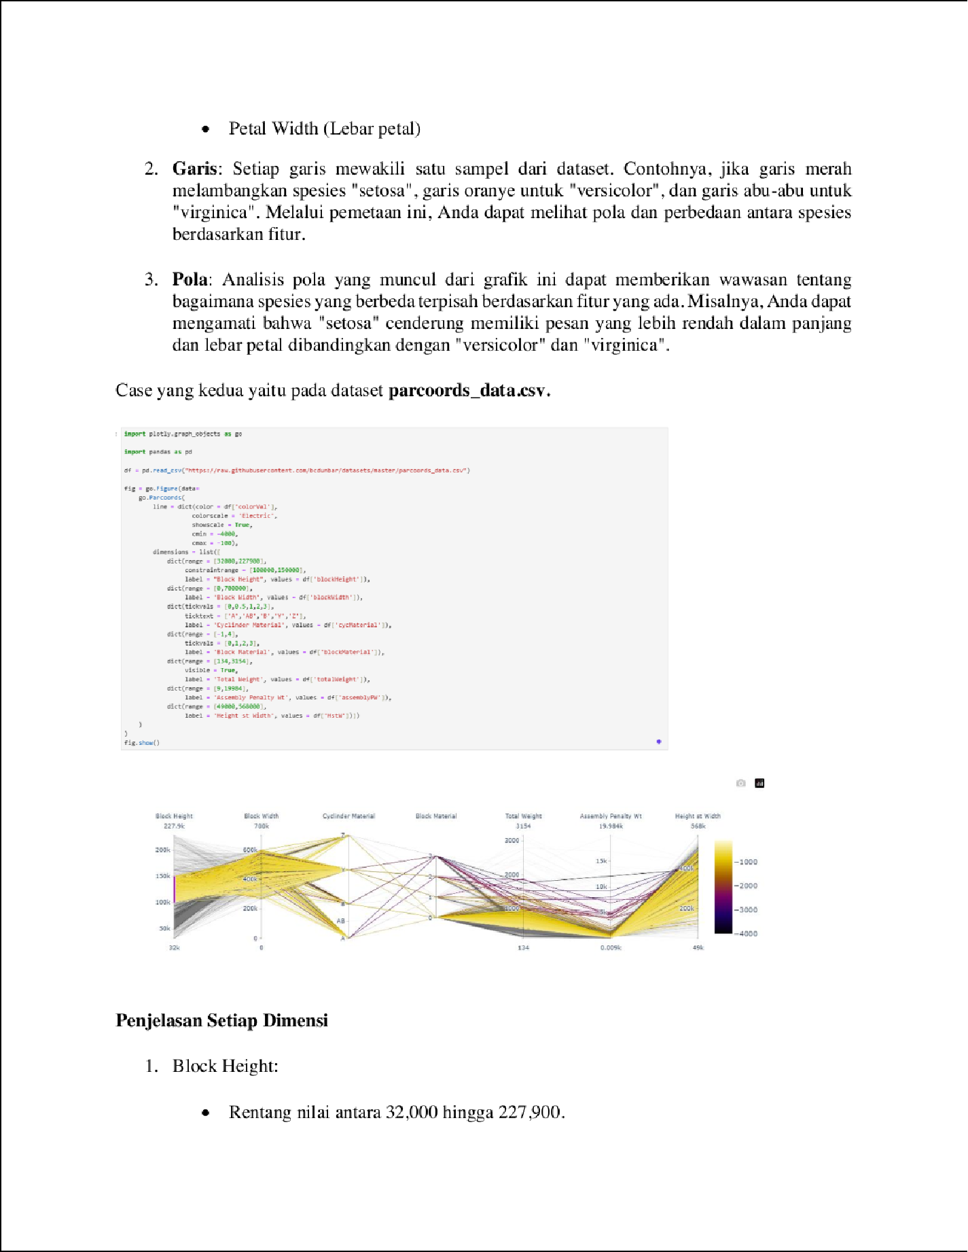

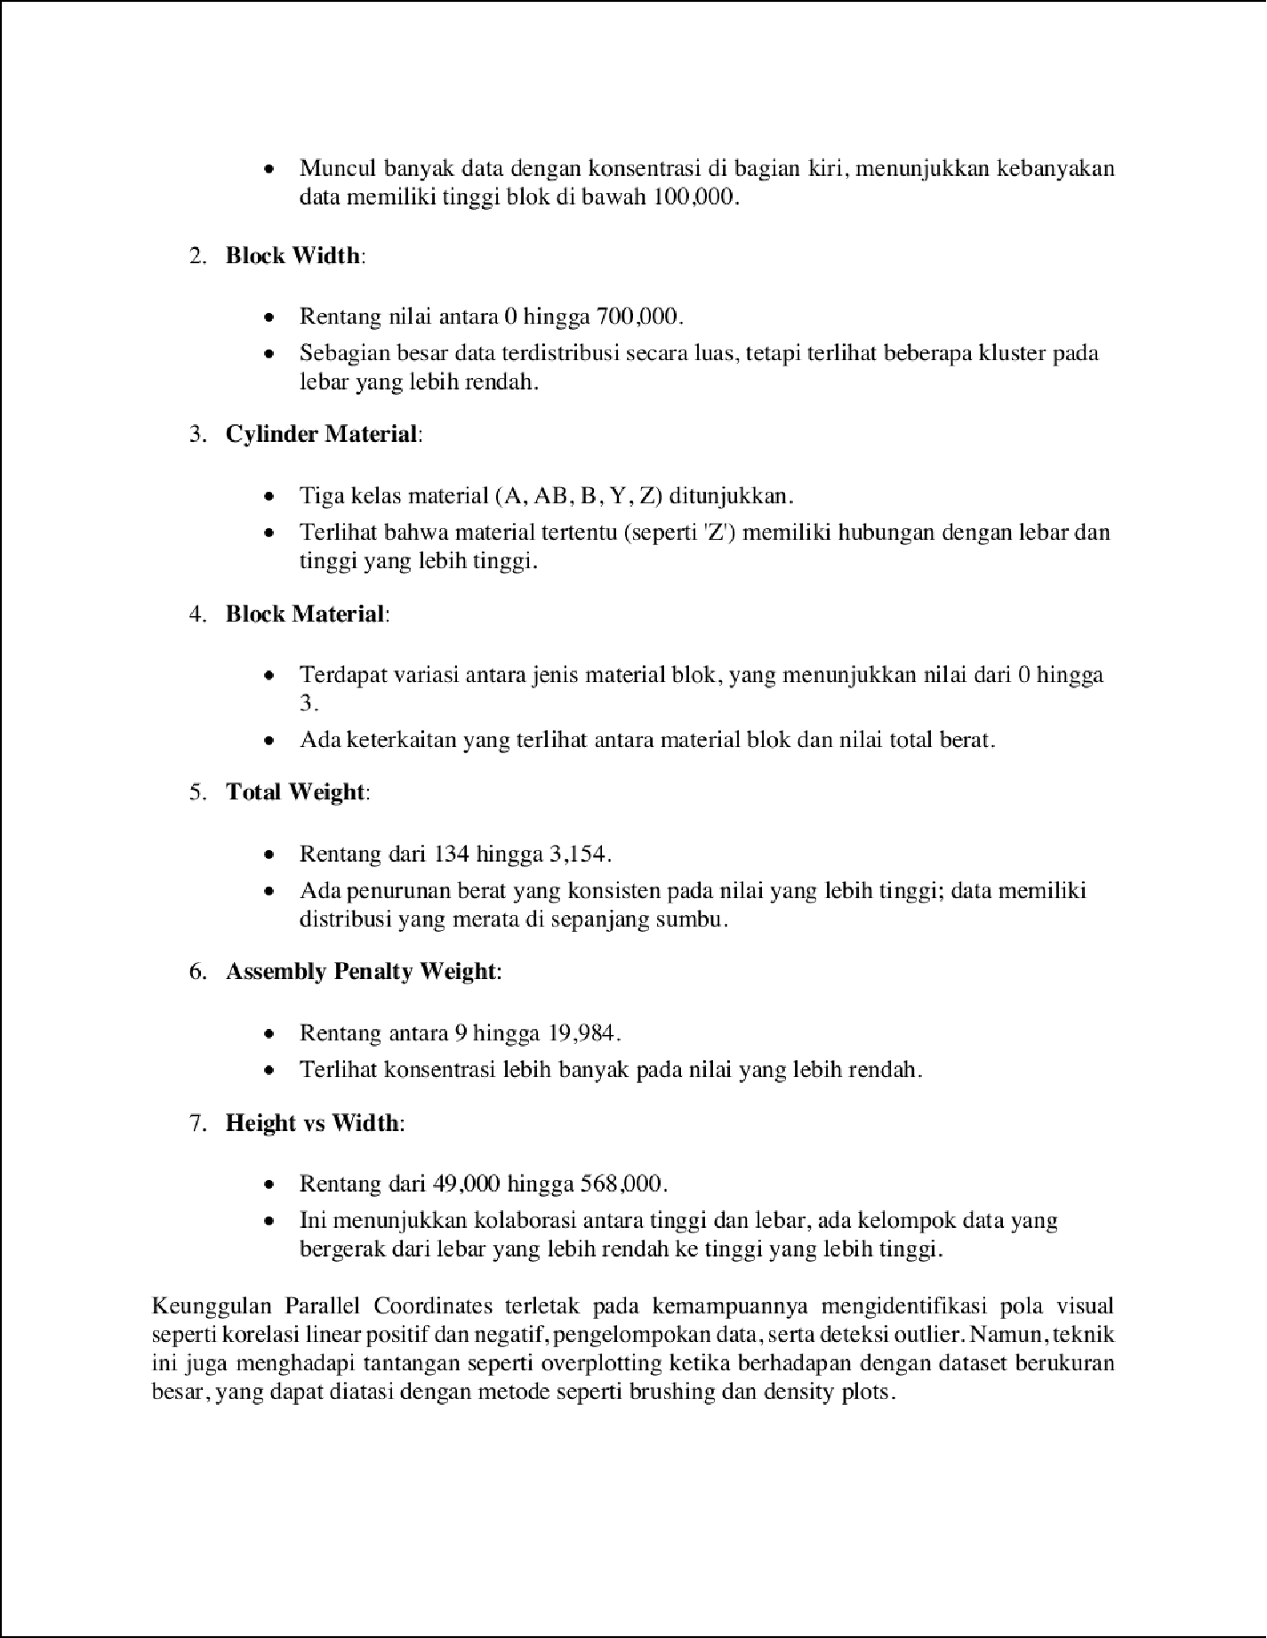

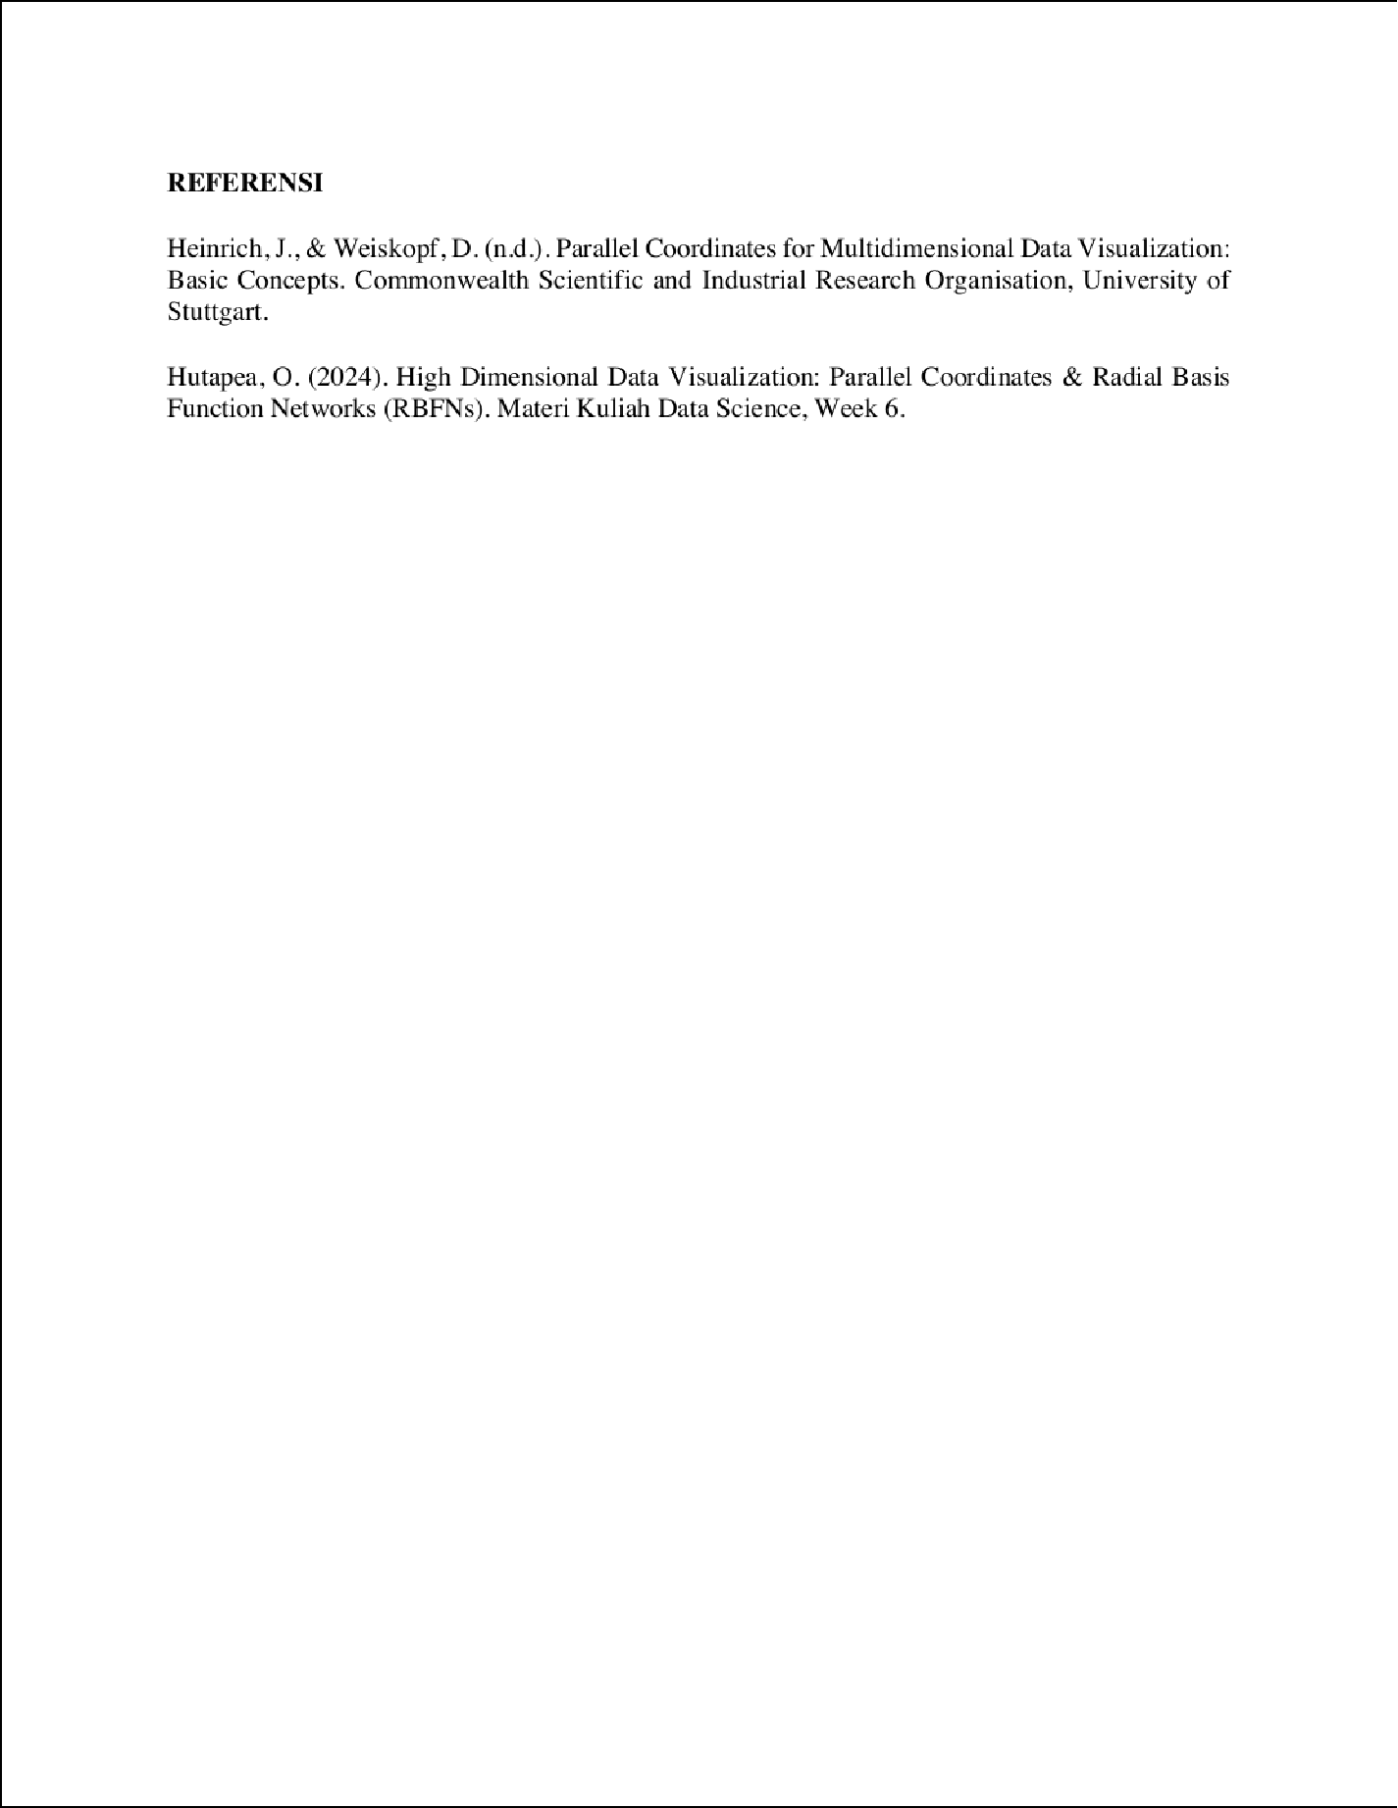

11422006_Parallel Coordinates

2

ORIGINALITY REPORT

%

## SIMILARITY INDEX

2%

## INTERNET SOURCES

1%

## PUBLICATIONS

%

## STUDENT PAPERS

PRIMARY SOURCES

# idschool.net

Internet Source %

1

1

1

# jurnal.wicida.ac.id

## Internet Source %

2

Exclude quotes On Exclude bibliography On

Exclude matches Off